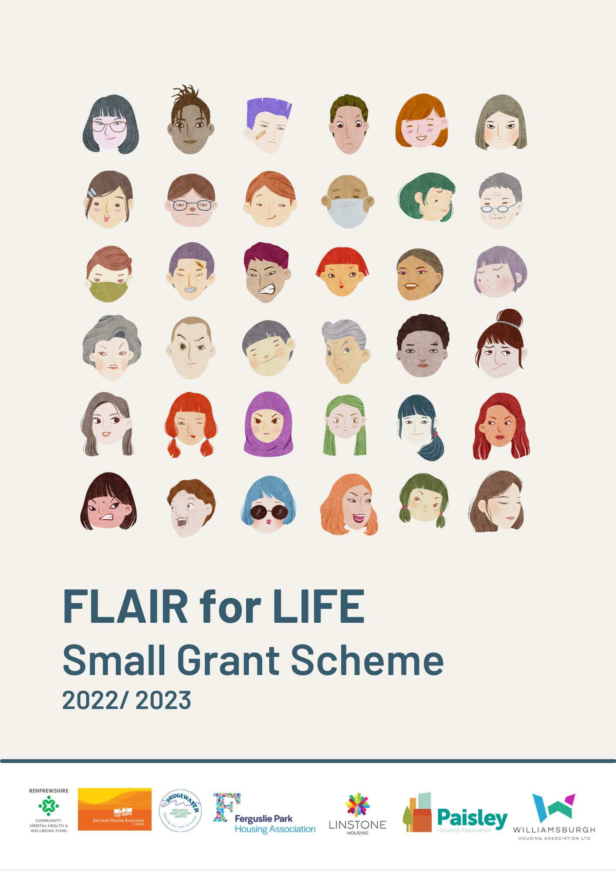
FLAIR is the Federation of Location Housing Associations in Renfrewshire and East Renfrewshire. The partnership of six housing associations includes Barrhead, Bridgewater, Ferguslie Park, Linstone, Paisley and Williamsburgh.
We recently received £30,000 from Engage Renfrewshire and the Scottish Government to give out to small groups with good ideas that promotes good mental health and wellbeing and tackles isolation and loneliness.

Who can apply?
- Any group can apply, you don’t have to be constituted or have a charity number
- If you are successful in being awarded funding for your idea and do not have a bank account we will work with you to find other ways to support you spend the money.
- If your group has received funding from Engage Renfrewshire’s Community Mental Health and Wellbeing Fund, you will not be eligible for funding from this programme.

How much is available
- You can apply for up to £1,500
- The total amount of money we have to distribute is £25,000

Funding is available for projects that
- Benefit and involve people from Renfrewshire
- Are good value for money
- Promote health and wellbeing or tackle loneliness and social isolation
- Will be complete by February 2023.

How to apply
- Return the completed application form to your local Housing Association contact
- If you need help, more information or have any questions, please get in touch with your local contact listed below.
- Your application will be reviewed against the criteria listed above by FLAIR partners, if we have any further questions we may get in touch.
- We will let you know if your project has been successful within a week.

List of local contacts
Bridgewater Housing Association
Kay Walker, Welfare Rights Officer
0141 812 2237
kwalker@bridgewaterha.org.uk

Ferguslie Park Housing Association
Jamie Mallan, Business Transformation Manager
0141 280 8801
jamiemallan@fpha.org.uk

Linstone Housing Association
Rachel Scott, Community Engagement Assistant
07500 946701
rscott@linstone.co.uk
Paisley Housing Association
Alan Graham, Advice and Projects Officer
0141 583 41232
alan.graham@paisleyha.org.uk

Williamsburgh Housing Associaiton
Stuart Miller, Community Regeneration Co-ordinator
0141 847 6393
stuartm@williamsburgh.co.uk

CONTACT DETAILS
Please provide us with the contact details of the person we should contact to let them know about the progress of your application
Group/ organisation name:

Contact person name:

Email:

Contact number:

HOUSING ASSOCIATION DETAILS
Prior to submitting your application, you should discuss it with your local Housing Association contact. They will be asked to support your application, and if needed provide further information.
Sponsor Association:

Contact person name:

WHAT IS THE ACTIVITY YOU WANT FUNDING FOR?
Let us know what you plan to do
What activities will take place?

When will these activities take place?

Who will be involved in these activities?

How does this promote good mental health and/ or reduce loneliness and social isolation?

How many volunteers will be involved in your activity?

How many people will benefit from your activity?

HOW MUCH WILL YOUR PROJECT COST?
We need to know how much your activity will cost; please provide a breakdown of your individual costs here.
Item | Costs

Total

