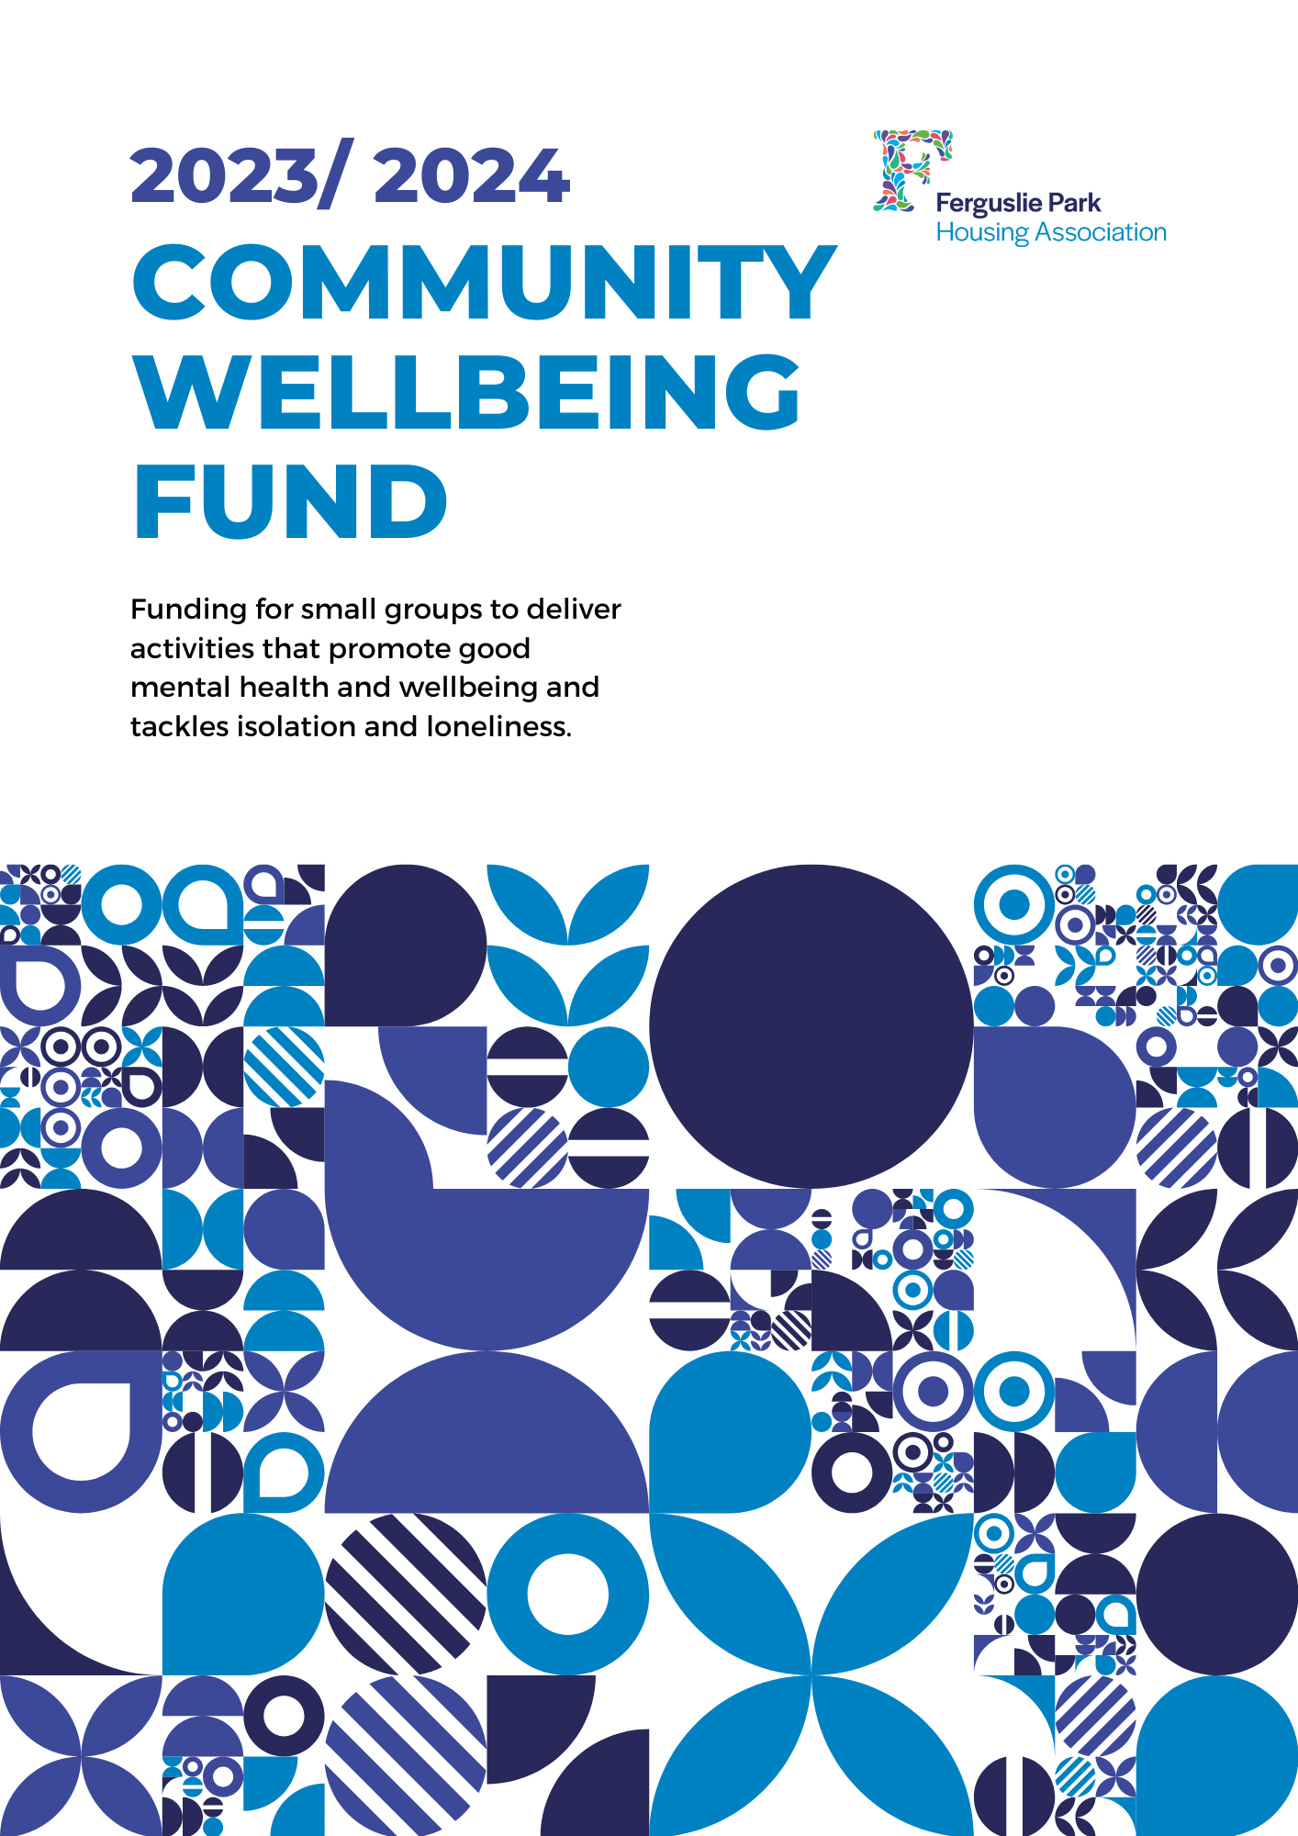

Ferguslie Park Housing Association have £4,000 to distribute to small community groups delivering activities that tackles isolation and loneliness or improve the mental health and wellbeing of people living in Ferguslie Park. This funding has been provided by Engage Renfrewshire and the Scottish Government through their Mental Health and Wellbeing Fund.

# Who can apply?

* Any group can apply, you don’t have to be constituted or have a charity number.
* If you are successful in being awarded funding for your idea and do not have a bank account we will work with you to find other ways to support you spend the money.
* If your group has received funding from Engage Renfrewshire’s Community Mental Health and Wellbeing Fund, you will not be eligible for funding from this programme.

# How much is available

* A total of £4,000 is available in the year.
* Whilst there is no maximum of minimum amount you can apply for, we aim to support at least six different projects this year.

# Funding is available for projects that

* Benefit and involve people over the age of 16 from Renfrewshire.
* Are good value for money.
* Promote health and wellbeing or tackle loneliness and social isolation.
* Will be complete by February 2024.

# How to apply

* Return the completed application form to [jamiemallan@fpha.org.uk](mailto:jamiemallan@fpha.org.uk).
* If you need help, more information or have any questions, please get in touch.
* Your application will be reviewed against the criteria listed above, if we have any further questions we may get in touch.
* We will let you know if your project has been successful within a week.



# CONTACT DETAILS

Please provide us with the contact details of the person we should contact to let them know about the progress of your application

|  |  |
| --- | --- |
| Group name: |  |

|  |  |
| --- | --- |
| Contact person name: |  |

|  |  |
| --- | --- |
| Email: |  |

|  |  |
| --- | --- |
| Contact number: |  |

# WHAT IS THE ACTIVITY YOU WANT FUNDING FOR?

Let us know what you plan to do

|  |  |
| --- | --- |
| What activities will take place? |  |

|  |  |
| --- | --- |
| When will these activities take place? |  |

|  |  |
| --- | --- |
| Who will be involved in these activities? |  |

|  |  |
| --- | --- |
| How does this promote good mental health and/ or reduce loneliness and social isolation? |  |

|  |  |
| --- | --- |
| How many volunteers will be involved in your activity? |  |

|  |  |
| --- | --- |
| How many people will benefit from your activity? |  |

# HOW MUCH WILL YOUR PROJECT COST?

We need to know how much your activity will cost; please provide a breakdown of your individual costs here.

|  |  |
| --- | --- |
| **Item** | **Costs** |

|  |  |
| --- | --- |
|  |  |

|  |  |
| --- | --- |
|  |  |

|  |  |
| --- | --- |
|  |  |

|  |  |
| --- | --- |
|  |  |

|  |  |
| --- | --- |
|  |  |

|  |  |
| --- | --- |
| **Total** |  |